KL Wolley
11/23/2018
Problem Set 12
Probability / Bayes Homework

- The probability of selecting the correct door is 1/3. The probability of selecting the wrong door is 2/3. Regardless of whether or not you have selected the correct door, the host will reveal an empty door. This does not change the probability of winning (i.e. selecting the correct door) as you will always be shown a door that is empty and you do not know what you selected. Although you would not switch to the empty door shown by the host, the probability remains the same 1/3 to win and 2/3 to lose.
- Suppose that instead of three doors, there are four doors in the Monty Hall puzzle. The probability of winning by NOT switching the door is ¼ (see Figure below).

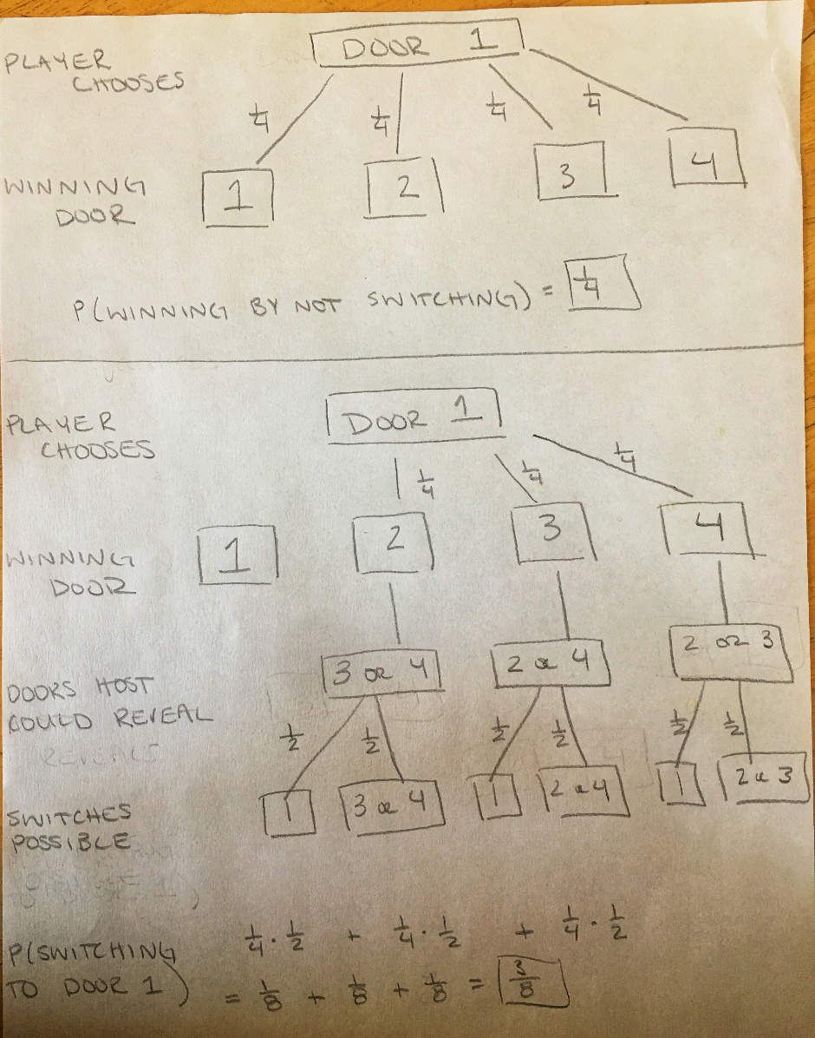

The probability of wining by changing the door selected to one of the two remaining doors among the three that was not selected is 3/8 (see Figure below).
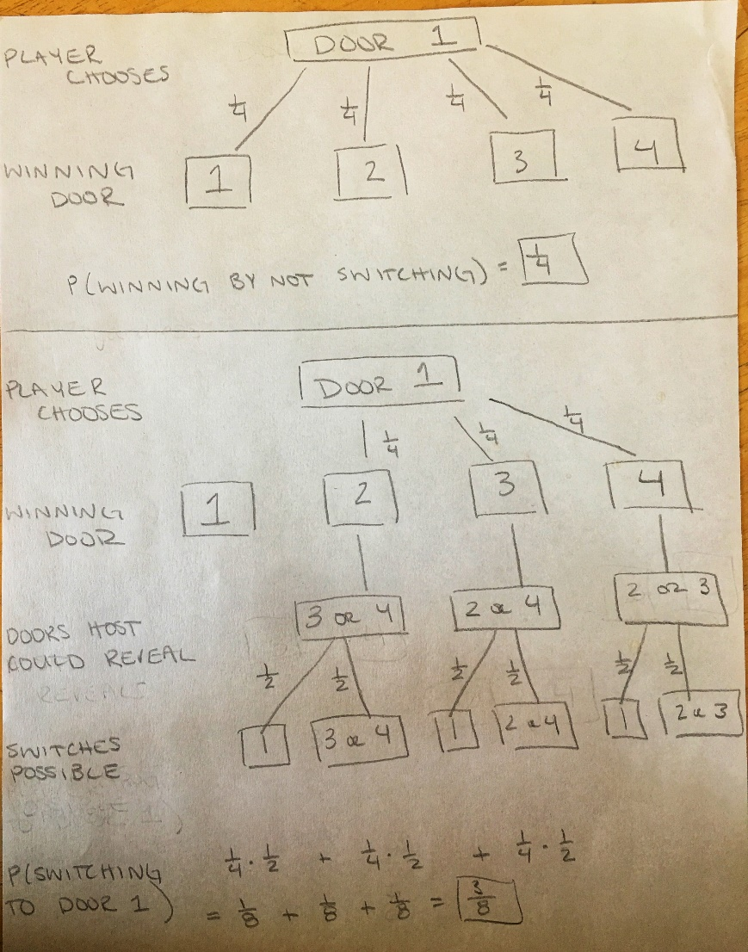

- The probability that two people chosen at random were born on the same day of the week is:
E = 1
Sample = 7
E/S = 1/7
- Probability that in a group of n people chosen at random, there are at least two born on the
same day of the week?
There are 7 days in the week. The probability of the randomly chosen people are born in DIFFERENT months is:
7 – (n-1) / 7 = 8 – n/7
Note that the n-1 accounts for the prior person to person n chosen at random.
Pn = 6/7 * 5/7 * … 8-n/7
Therefore the probability of n people chosen at random with the SAME birth month is:
1 – Pn
- How many people chosen at random are needed to make the probability greater than 1/2 that there are at least two people born on the same day of the week?
Case by case test:
P(4) = 6/7 * 5/7 * 4/7 = 0.350
1 – P(4) = 0.650
P(3) = 6/7 * 5/7 * 4/7 = 0.612
1 – P(3) = 0.388
P(3) is not > 0.5 therefore the minimum number of random people is 4.

  - If we assume that birthdays are equally likely to occur on any month, the probability of two people having the same birthday is 1/12 as there are 12 months out of the year.
E = 1 – only one month shared between people
S = 12 – months of the year
E/S = 1/12
  - The probability that in a group of n people chosen at random, there are at least two born in the same month of the year?
The probability of n people chosen at random with DIFFERENT birth months is:
12 – (n-1) / 12 = 13 – n/12
Note that the n-1 accounts for the prior person to person n chosen at random.
Pn = 11/12 * 10/12 * 9/12 * 13-n/12
Therefore the probability of n people chosen at random with the SAME birth month is:
1 – Pn

  - How many people chosen at random are needed to make the probability greater than 1/2 that there are at least two people born in the same month of the year?
Case by case test:
P(6) = 11/12*10/12*9/12*8/12*7/12 = 0.223
1 – P(6) = 0.777

P(5) = 11/12*10/12*9/12*8/12 = 0.3819
1 – P(5) = 0.618

P(4) = 11/12*10/12*9/12 = 0.5729
1 – P(4) = 0.427
P(4) is not > 0.5 therefore the minimum number of random people is 5.

